**Title:** Create a Project:

* Using Python IDE and Configure Project
* Executing the program using Command Prompt
* Create Project Repository in Github (using PyCharm IDE)

**Objective(s):**

Upon finishing the lab, student will attain mastery of the following:

* Configure Project to execute Python Scripts
* Executing Python Scripts via Command Prompt
* Creating Repository and update code in Github (Using PyCharm IDE)

**Tools, Equipment and Materials:**

1. Personal Computer with Internet Access
2. Operation System with Installation of Python Software / Python IDE (e.g. PyCharm)
3. Git Software

**Instructions:**

1. In this lab, you'll learn how to create a new project using PyCharm.

**Create a Project**

1. Start PyCharm IDE, you will be asked to create a new project for the very first time.

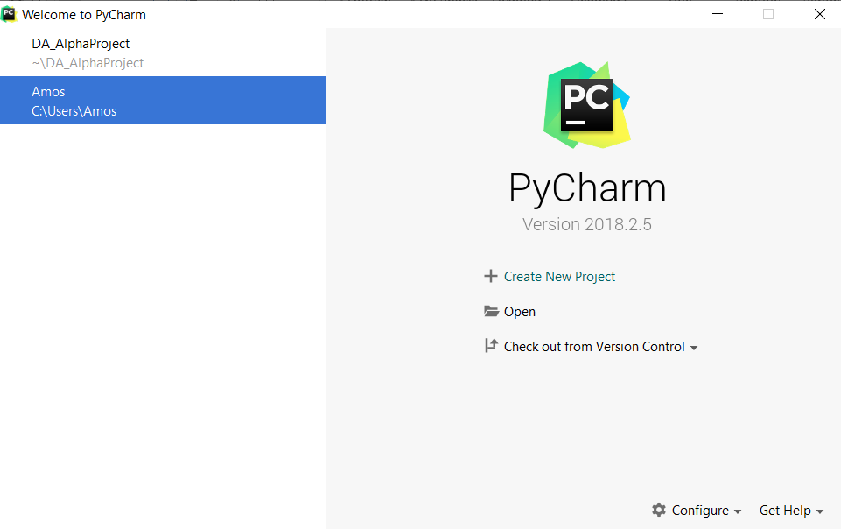

1. Click on the + Create New Project to start the project, then followed by Pure Python and change the default location – **untitled** to **PY_Project** before Clicking Create.

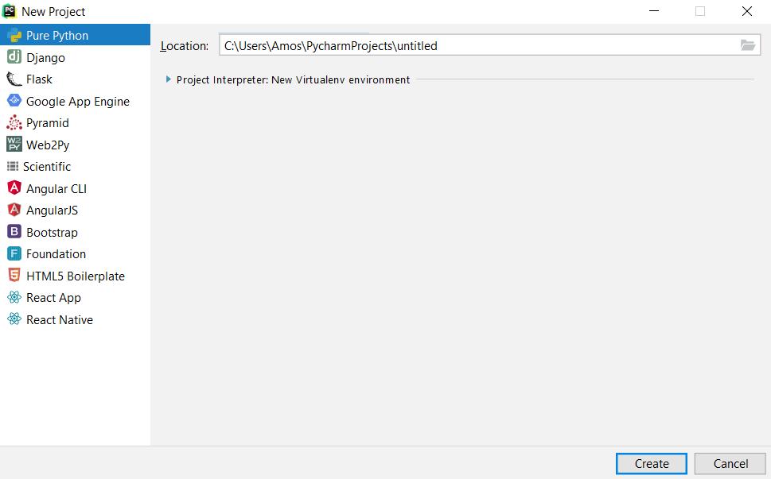

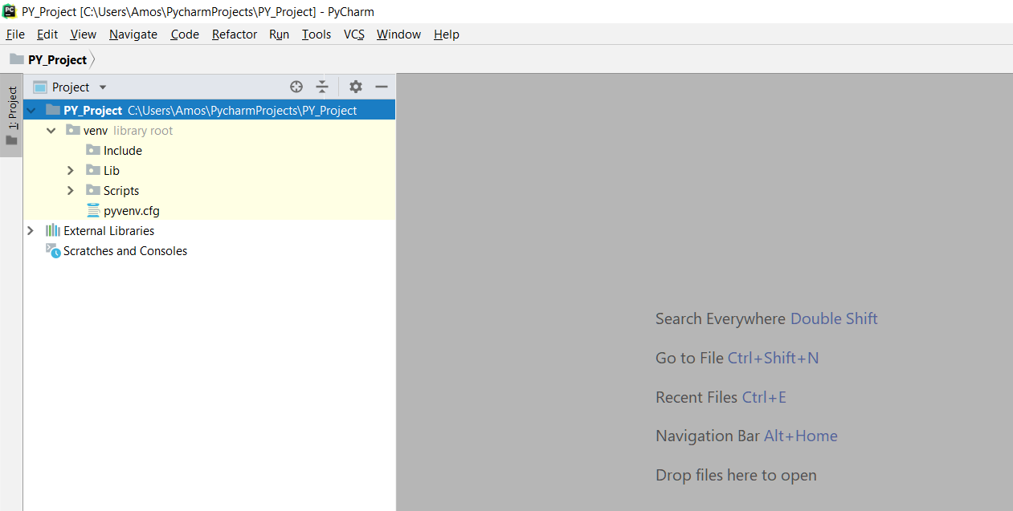

**Create a Python Script**

1. A default Project Structure is created by PyCharm. Right-Click PY_Project -> New -> Python File to create a python script for your program.

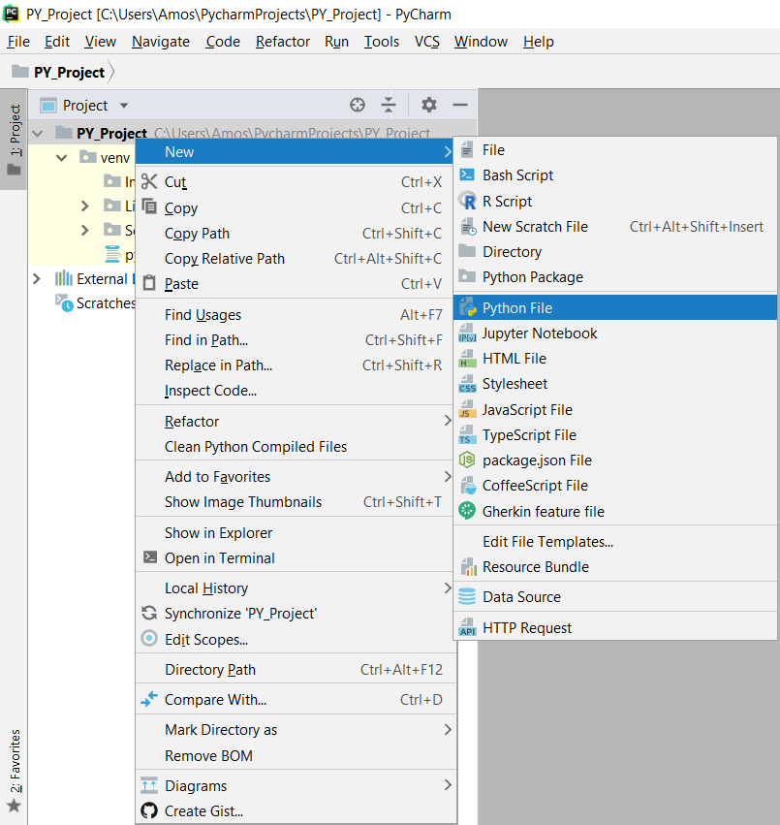

1. Create Python script named myProgram and use the default selection for Kind – Python file and click OK.

|  |  |
| --- | --- |
|  |  |

**Create Project Configuration**

1. Under the project, myProgram.py file is created as shown above. In order to run the program, there is a need to click the Add Configuration button just below the menu bar on the right.



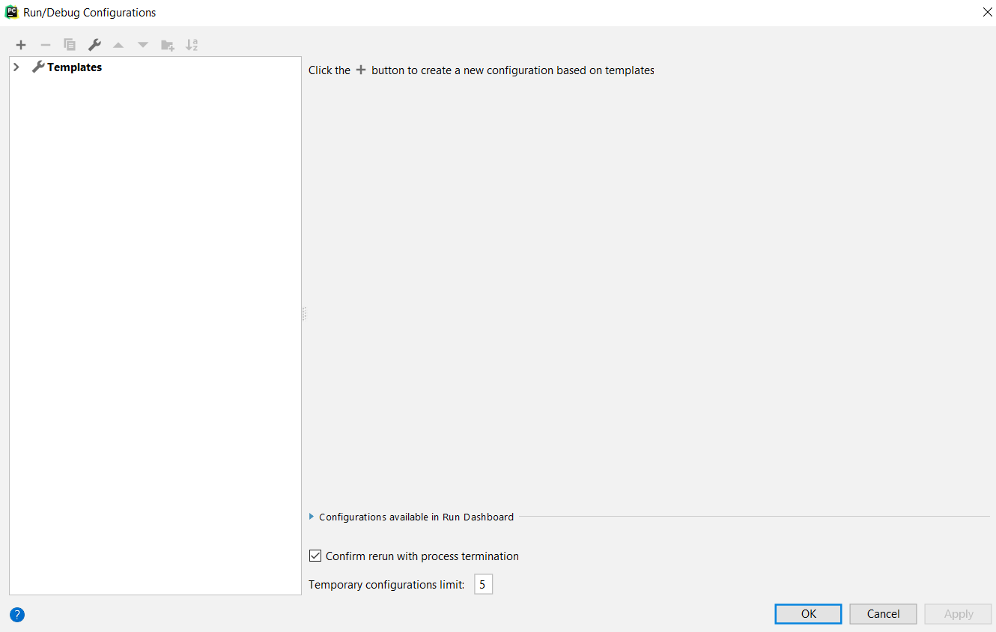

1. Click on the > Templates to select Python under the templates and select the Python interpreter to Python 3.X (PY_Project) before clicking OK.

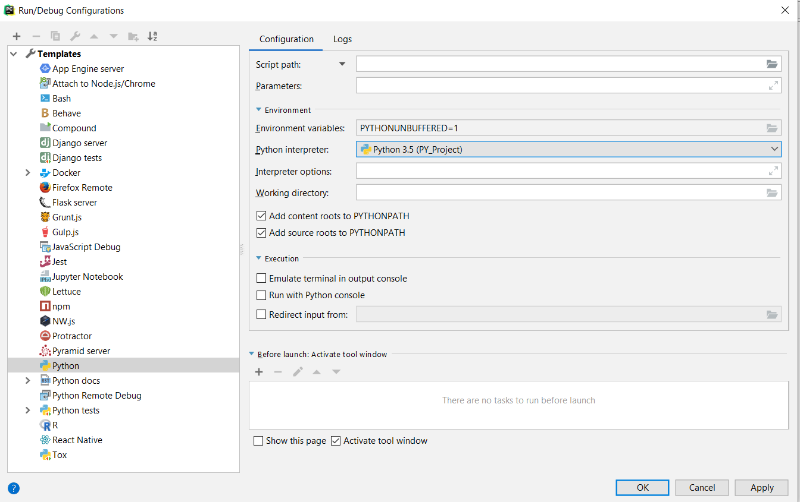

1. With the configuration set, you will be able to run the program as shown below. After the run, you will have selected the configuration set **myProgram** as shown below:

|  |  |
| --- | --- |
|  |  |

1. Nothing is shown in the program as the script is empty. To test, you may write a print(‘Testing’) function and when run, it will print the word Testing in the console and your project has been configured to run python script in the project.

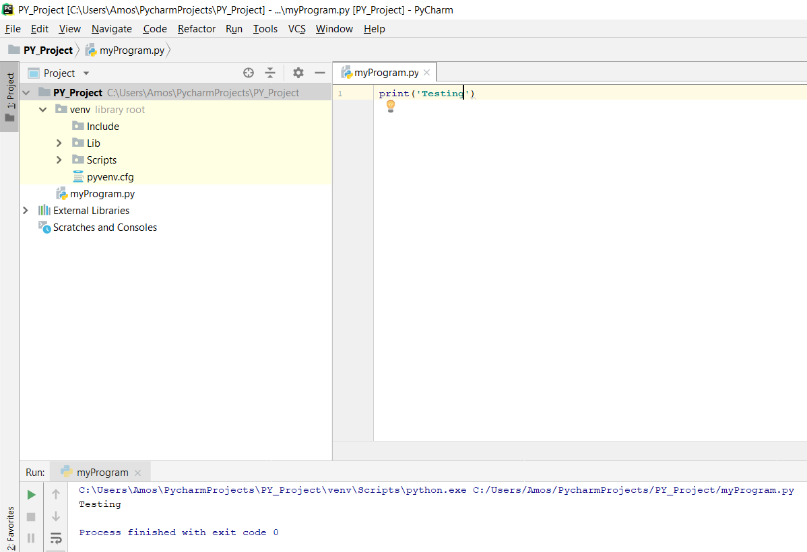

1. You may also choose to open a command prompt(for windows) or Terminal (for non-windows), and go to the project folder and run myProgram script and ‘Testing’ will be printed as shown below:

|  |  |
| --- | --- |
|  |  |

1. The simplest Python Project will only have one python scripts. You may wish to use a notepad to create a .py extension file or use echo command > otherProgram.py to create file as shown above.

**Code the Program**

1. You may wish to use the previous lab exercise to create myProgram and execute it as shown below:

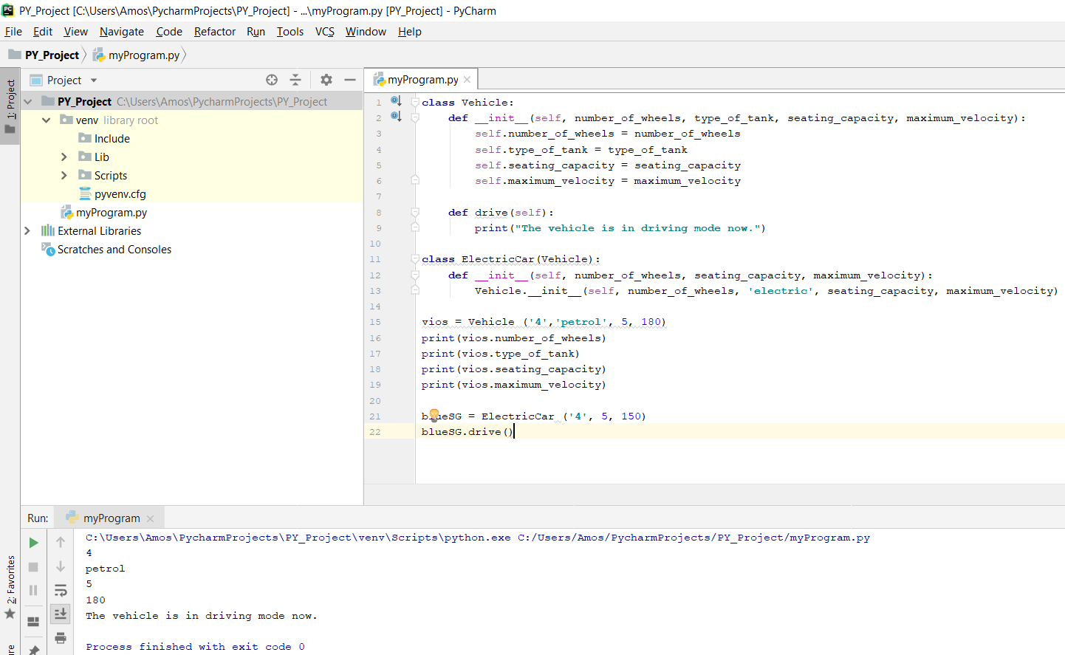

**Setup GitHub Account**

1. In order to create a Github project, user will needs to be member of Github. If you do not have an account, kindly go to the website to sign up for a new account. There will be a request for Username and password for integration.

|  |  |
| --- | --- |
|  |  |

1. Once you have signed up and signed in. You will be bought to a page which allows you to create new repository to store your project.

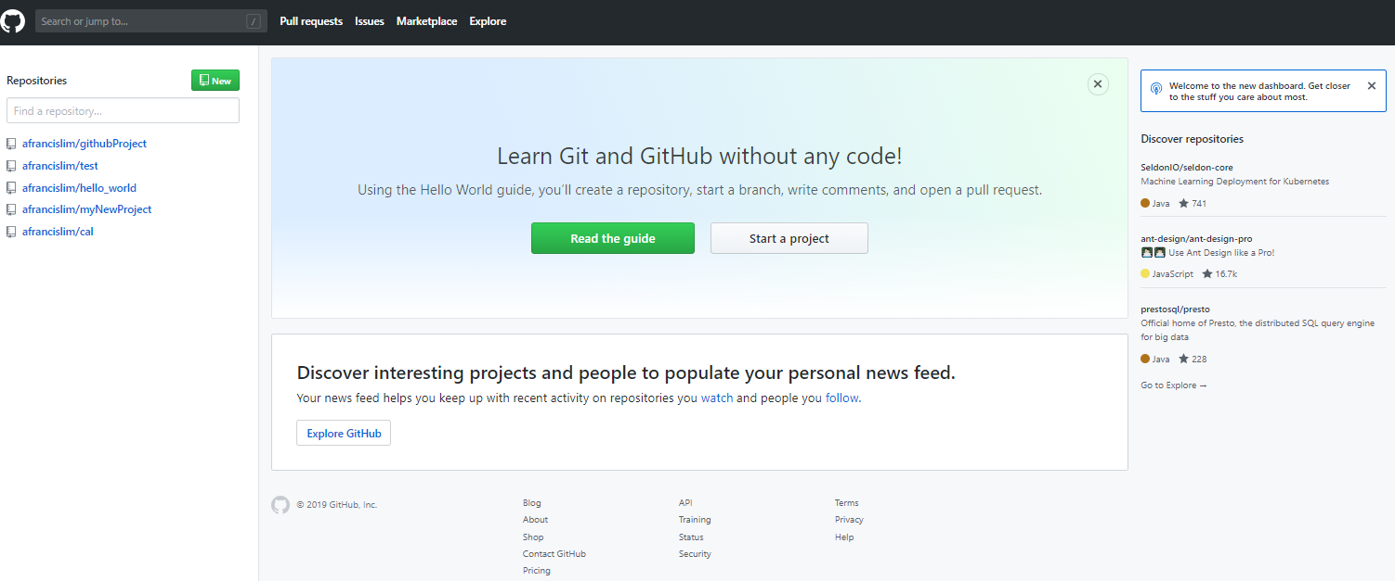

**Create a Github Repository by sharing Project with GitHub using PyCharm**

1. Go to PyCharm to link up your source code with Github by click on Enable Version Control Integration under VCS menu. Select Git as the project root to be associated. You might be prompted with an error due to setup or no git.

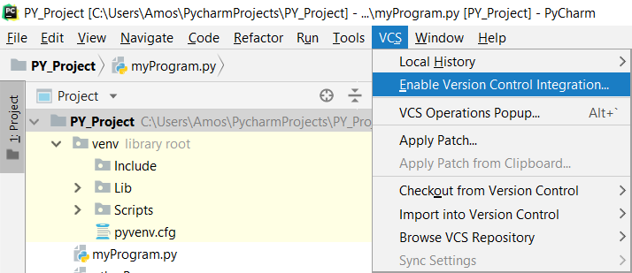

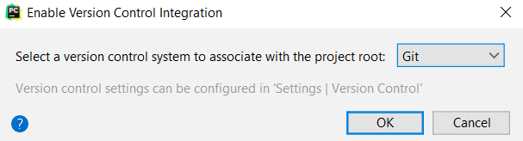

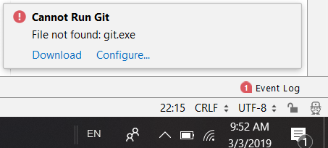

1. Click on Configure first to setup your Github as shown above. Select Github as shown below to add account. Enter Username and password of Github account and upon authenticated successfully, your account will be shown in the listbox below.

|  |  |
| --- | --- |
|  |  |

1. To create a project in GitHub, go to VCS menu and Share Project on GitHub as shown below. After which, you will see the repository being created in GitHub.

Go to Git🡪Github🡪Share project on GitHub

|  |  |
| --- | --- |
|  |  |
|  |  |

**Installation of Git**

1. To integrate Git with PyCharm, there is a need to download and install Git. Click on the **download** and the browser will bring you to the download page and download 64 bit Git for Windows Setup.



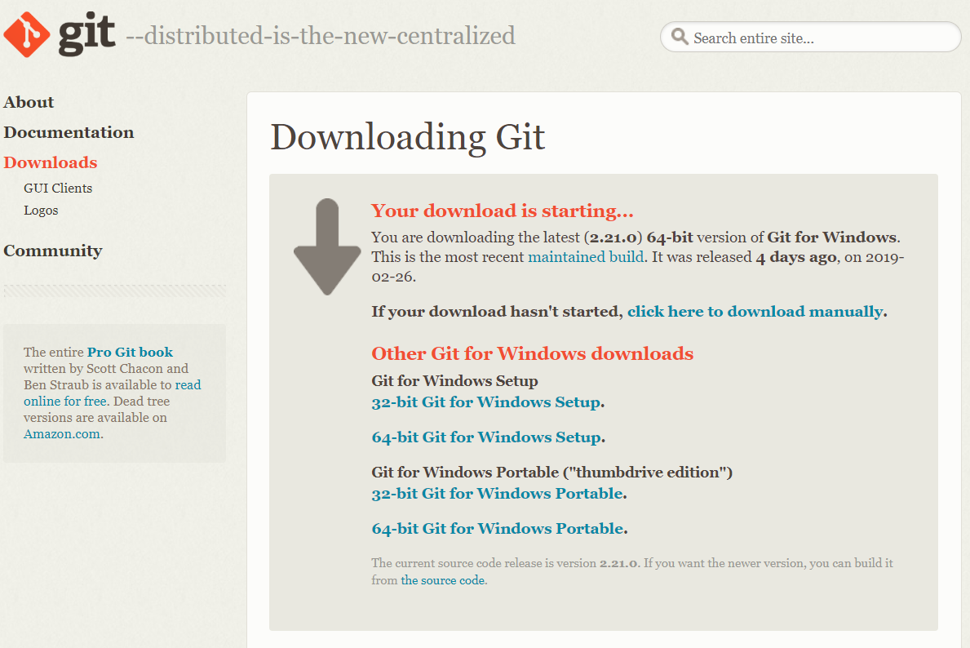



|  |  |
| --- | --- |
|  |  |

|  |  |
| --- | --- |
|  |  |

|  |  |
| --- | --- |
|  |  |

|  |  |
| --- | --- |
|  |  |

|  |  |
| --- | --- |
|  |  |

|  |  |
| --- | --- |
|  |  |

1. Click on the VCS and you will see other options after the installation.

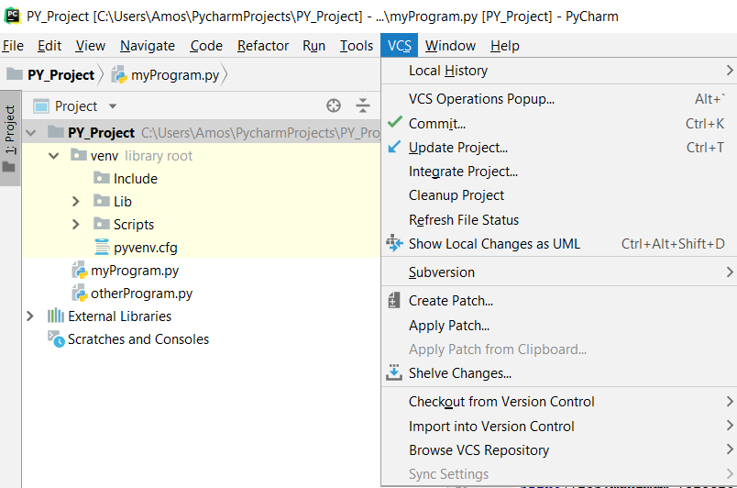

1. To configure for Git, Go to File-> settings, set the path to Git/bin/Git.exe and click OK.

|  |  |
| --- | --- |
|  |  |

**Comparison of code change**

1. If you make some changes to the code, you can easily compare your code to the original code(master) and see the differences as shown below:

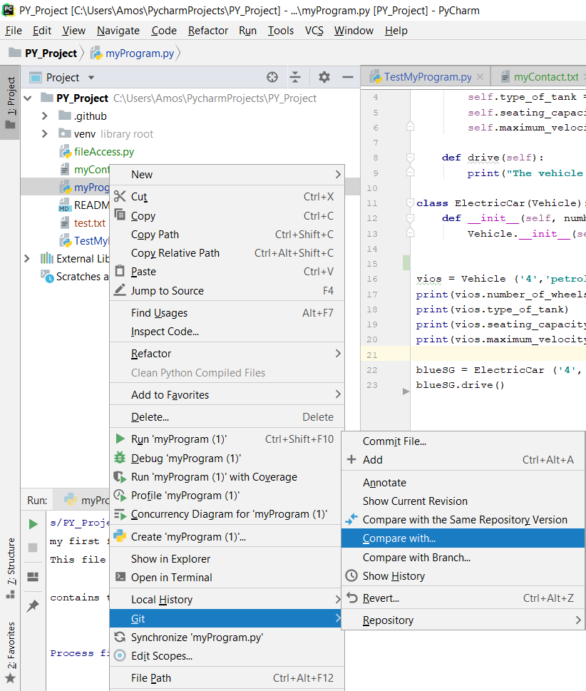

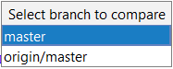

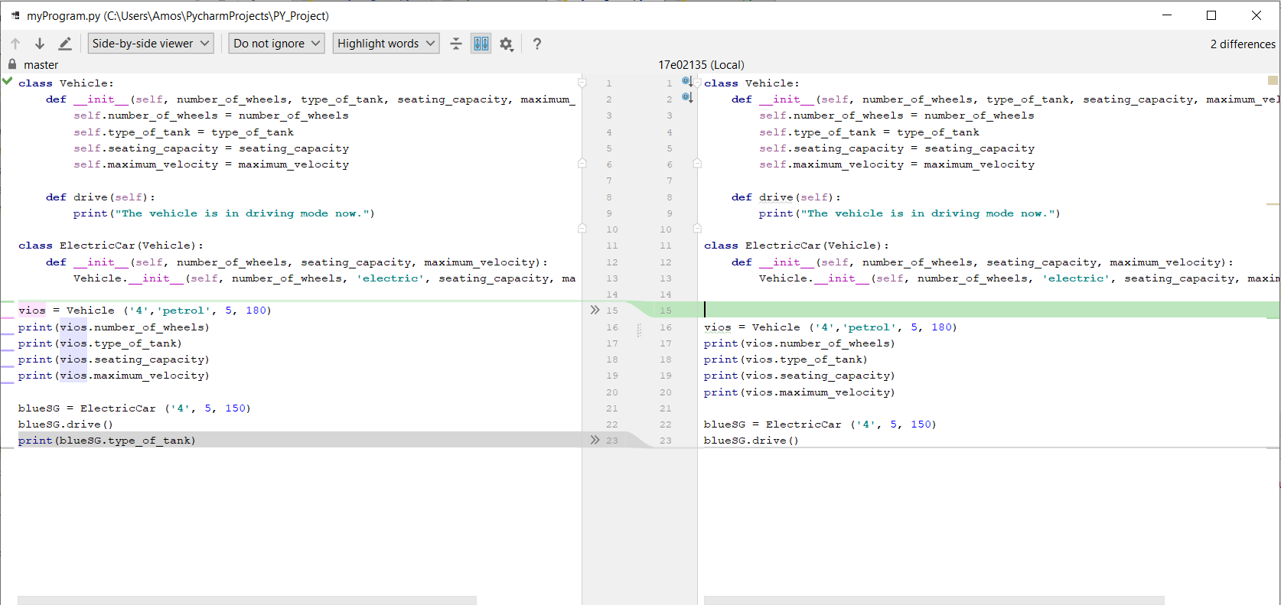

1. Create a Python file name as demoVcs.py
2. Create a class name Calculator.
3. Create 2 functions: add() and minus() to perform the sum & difference and print the result.
4. Pass 2 numbers, num1=50, num2=40 to the 2 functions.
5. Commit the file and push to your GitHub repository.
6. Add another function, multiply() to perform the product of the 2 numbers.
7. Right click on the demoVcs.py 🡪Git🡪Compare with revision🡪File revision🡪 Select the latest File revision.
8. Now, commit and push to your GitHub. Comments 🡪 Added multiply function
9. Compare the files, you will notice that the files has been updated in your Github.
10. Login to your Github account and observe the updated demoVcs.py contents.

Note: to dele the repository click on the repository🡪setting🡪scroll down🡪Danger zone🡪delete

- END -